Lahore Garrison University
DHA Phase 6 Lahore



Student Name | Muneeb Ur Rehman
Student Roll No | Fa-2023-BSCS-490
Section | D
Subject | Web Technology
Instructor Name | Mr. Muhammad Yousaf

Lab 3: HTML Basics — Structure & Semantic Markup

Step-by-Step Breakdown

🔧 1. Setup Your Environment
- Install Tools:
  - VS Code
  - Live Server Extension
  - W3C HTML Validator
- Create Project Folder:
  - Name it something like lab3-html-basics
  - Inside, create index.html

2. Build Semantic Structure in index.html
Use semantic HTML5 tags to organize your page:
<!DOCTYPE html>
<html>
<head><meta charset="UTF-8"><title>My Page</title></head>
<body>
<h1>Welcome</h1><p>Short intro</p>
<a href="#about">About</a> | <a href="#projects">Projects</a> | <a href="https://github.com/">GitHub</a>
<h2 id="about">About Me</h2>
<p>Brief bio</p><img src="profile.jpg" alt="Me" width="100">
<ul><li>Punjab</li><li>Web Dev, AI</li><li>English, Urdu</li></ul>
<h2 id="projects">Projects</h2>
<ul><li><a href="p1.html">P1</a></li><li><a href="p2.html">P2</a></li></ul>
<p>©2025 Muhammad | <a href="mailto:muhammad@example.com">Contact</a></p>
</body> </html>

3. Add Content Elements
- Images: Use .jpg, .png, or .svg with descriptive alt attributes.
- Lists: Use <ul> or <ol> for facts, links, or features.
- Links:
  - Internal: href="#section-id"
  - External: href="https://..." with target="_blank" if needed.

4. Accessibility Basics
- Use meaningful alt text for all images.
- Ensure link text is descriptive (avoid "click here").
- Use proper heading hierarchy (<h1> to <h3>).
- Label navigation clearly.

5. Validate HTML
- Go to W3C Validator
- Upload or paste your HTML code.
- Fix any warnings or errors (e.g., missing alt, unclosed tags).

6. Final Deliverables
Requirement | Description
✅ Semantic Usage (4) | Use of header, nav, main, article, aside, footer
✅ Accessibility (3) | Alt text for images, clear labels, heading structure
✅ Validation (3) | Pass W3C validation with no errors or warnings
✅ Hosting | Push to GitHub repo or local server using Live Server
✅ Report | Save validation screenshot or summary in repo (e.g., validation.txt)

CODE
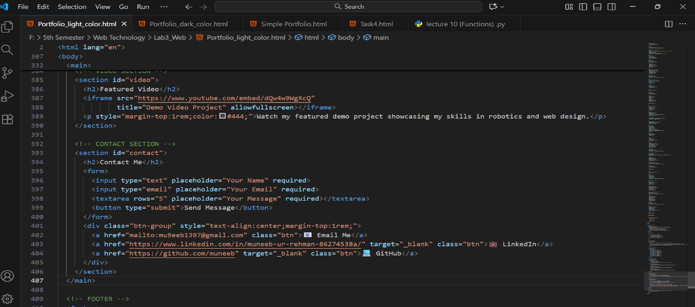
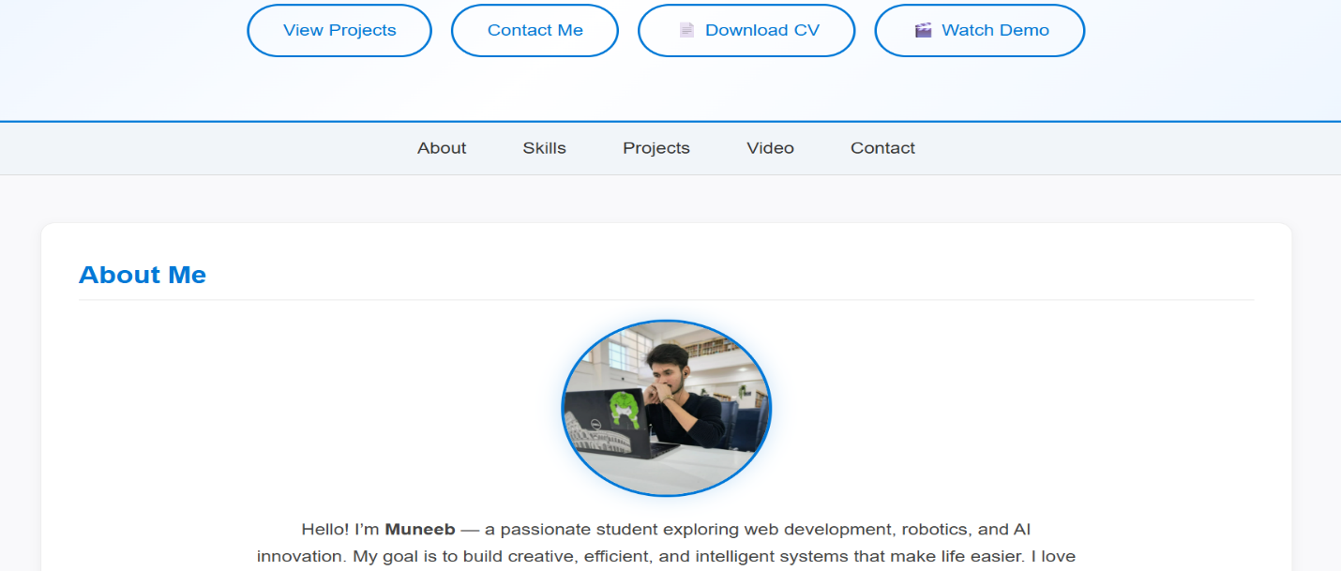
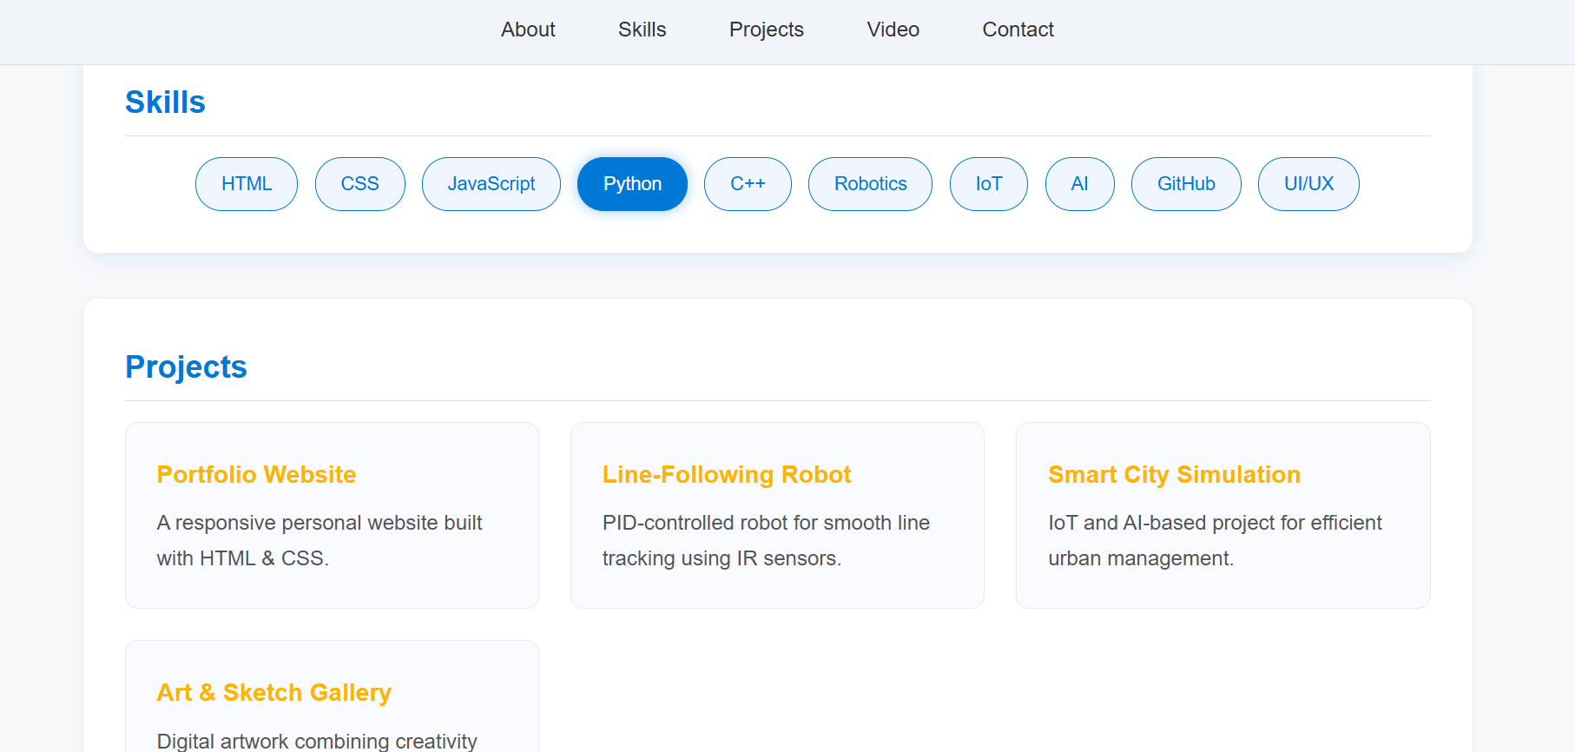

CONCLUSION:
________________________________________________________________________________________________________________________________________________________________________________________________________________________________

RUBRICS:

Performance |  |  | Lab Report
Description | Total Marks | Marks Obtained | Description | Total Marks | Marks  Obtained
Ability to Conduct practical | 5 |  | Structure | 5
Data Analysis & Interpretation | 5 |  | Efficiency | 5
Total Marks obtained |  |  | Total Marks Obtained

Instructor Signature

